EBL Parent Involvement in K-12 Education Review
Sonia Lazzereschi
University of Miami

Abstract
Engaging parents as partners and advocates is imperative for their children’s academic success. The school system should pay more attention to English Bilingual Learners (EBL) who face numerous educational challenges to minimize the academic gap between them and their English-speaking peers, including parent engagement. Research shows that when parents get involved in their children’s education they perform better in school. This review explores the reality that EBLs and their parents face, the importance of parent involvement in school, parents’ perceptions of English as a second language programs, barriers that stop parents from participating in their children education, and some successful traditional and non-traditional strategies to improve parent participation in the context of their child’s academic development.
Keywords: parent involvement, English bilingual learners (EBL), strategies, school system, children education, engaging parents.

EBL Parent Involvement in K-12 Education Review
According to the National Center for Education Statistics (2016), the number of English Bilingual Learners (EBLs) enrolled in K-12 public schools in the United States, for the school year 2014-2015, was 4,803,579. Among these students enrolled in the English learning programs, 78% were Hispanic. Moreover, according to Maxwell (2012), by 2020, in K-12 public schools in the U.S., one of every four students will be Hispanic. Therefore, the system should start paying more attention to Hispanic students, who currently face numerous educational challenges, including academic failure and lack of resources to enhance their literacy skills (Olson, Matuchniak, Ching, Stump, & Farkas, 2017). Doing so would help minimize the gap between EBLs and English proficient students, ultimately benefitting the entire public-school system.
Research has shown that when parents get involved in their EB children’s education, students’ achievement improves, they are absent from school less, and the dropout rates decrease. Therefore, the schools district, administrators and teachers must work together to identify and implement practices to support parents’ involvement in EBL education.
The United States school system serves students from numerous backgrounds. The different educational cultures of these ethnic groups influence the way parents perceive their role in the education of their children. Sometimes EBLs parents’ behavior is perceived as lack of interest in their children’s education, but in most cases, it is just a reflection of their ignorance regarding the ways in which the school system works, and unfamiliarity with what the system expects from them.
This review presents a summary of different aspects of parents’ involvement in their EBLs education. It will consider discrimination against EBLs and their parents, the importance of parental involvement, the barriers that EBL parents must overcome to get involved in their children’s education, the different views of teachers and parents with respect to EBL education, and successful strategies to improve parental involvement.

The reality that EBLs and their parents face
Even though most EBL students are U.S. native-born, their academic future may always be negatively impacted simply because they come from immigrant families. Therefore, a lot of these students and their parents are isolated and discriminated for their background and socioeconomic status. Also, there are a lot of schools where most of the students are EBLs, therefore they do not have the opportunity to socialize with English-speaking classmates. This makes it even harder to teach EBL students and involve their families in their children’s education.
Moreover, it is very common that EBLs converge in high-poverty schools that lack well-prepared teachers and instructional resources. As a result, EBLs receive poor academic instruction.
In most cases, EBLs’ parents have a low level of literacy in their native language and a lot of them do not even have a high-school diploma. Due to their race, class, immigrant status, language proficiency and level of education, many EBL parents fit the description of a marginalized group (Arias, Morillo-Campbell). However, research has shown that these parents care a lot about their children’s education. This is why it remains imperative that EBL teachers find a way to reach and help involve these parents in the academic development of their children.
Hispanic EBLs often find themselves in a disadvantaged environment where they are surrounded by extraordinary challenges to their well-being (Schneider, Martnez, & Ownes, 2006), adding yet another challenge to their educational progression.

The Importance of Parental Involvement
Parents’ engagement in their children’s educational activities is a key factor to ensure a positive influence in students’ academic performance. From children’s perspectives, their parents’ involvement is more influential to their academic performance (Hoover-Dempsey et al., 2005). According to research (Jeynes, 2005) a positive, medium effect on academic performance was found from educational interaction between parents and children. It was also found that when parents participate in children’s academic activities with encouragement from teachers, this results in the equivalent of a 4 to 5-month improvement in reading or math performance (Rivera, Li, 2019).
Moreover, research studies have shown that children whose parents are actively involved in their education: adjust easier to school, obtain higher grades, do not miss school, achieve their academic goals, behave better, and develop social skills faster. It’s also important to note that when a school engages more parents, all children benefit, according to a 1995 study called A Generation of Evidence: The Family is Critical to Student Achievement (Wolpert-Gawron, 2019).
According to Lara-Alecio, Irby, & Ebener - 1997, parent behaviors supported by schools and teachers will encourage more achievement by Hispanic students, such as (a) has high academic expectations, (b) sets high expectations in the completion of school, (c) connects education with success, (d) expresses desire and acts to further their education, and (e) acts as a role model for acquiring an education.
Unfortunately, there is evidence that some teachers may discourage EBL parents’ participation in school curricular activities because they believe that parent’s first language interaction with their children interferes with their second language learning (Cummins, 1986). However, this belief has been refuted by many scholars (Coelho, 2004; Cummins, 2005). Educators must recognize and value students’ first language as part of their identity, as a tool to think and learn, and as a valuable way to communicate with family and community members.

EBLs Parents Perceptions of English as a Second Language (ESL) programs
It is very important to consider EBLs parents’ perceptions of ESL programs because these perceptions directly affect students’ success. Parents perceive ESL programs depending on how much information about these programs schools make available to them. According to the study “ELL Parents’ Perceptions Matter” by Cynthia E. Lueck, parents’ perceptions depend on (a) lack of program information or clarity, (b) parental attitudes toward ESL services available in school, (c) views on English proficiency initial testing, (d) children’s emotional development, and (e) structure of the program and strengths and benefits.
As a result of the study mentioned above, the author identified an area for improvement: program information must be available to parents in a language that they can understand. This program information should include admission criteria, curriculum and instruction, and a calendar to inform parents of testing and important activities.

Barriers that Impede Parents from Participating in their Children’s Education
Parents of EBLs confront a lot of barriers which limit them to get involved in their children’s education. Some of these barriers are:
- Lack of English proficiency, which is the major barrier when communicating with teachers. It prevents parents from approaching school personnel and teachers to ask questions or express their concerns or thoughts about their children’s education and academic progress. According to Scarcella (1990), “frequently, ESL parents avoid going to schools because they cannot communicate in English, and there is no one at school who speaks their native language”. Additionally, the school system does take EBL parents into consideration when they use English-only in most of the formal communications sent home with students. Similarly, the school system uses specialized terminology and acronyms that are foreign to most EBL parents.
- The school system intrinsic barriers, such as a negative school climate, a negative view of EBL parents, and a unidirectional strategy for parental involvement. EBL’s parents are perceived as lacking resources to support their children at home. Teachers think of them as people with no education, experience, or enough preparation to support their children to accomplish their academic goals. The lack of participation of some parents in school-related matters is interpreted as lack of interest.
- EBL parents’ level of education and unfamiliarity with the U.S. school system is another obstacle for parent involvement. Both aspects limit these parent’s ability to support their EBL’s educational development and their participation in school activities. Moreover, many parents are unable to give their children academic advice because they are not familiar with the school system.
- Differences between the culture at school and that at home, such as parents’ perception of their role in their children’s education. EBL parents think that they are responsible for nurturing, teaching values, and inculcating good behaviors. They expect teachers to be completely responsible for providing their children with all the academic preparation and support they need to accomplish school goals. EBLs’ families practice and promote collectivism, while schools encourages individualism.
- Issues related to school logistics limit parents to be present in school. Usually, parent workshops and parent-teacher conferences take place at times when EBL parents are at work, so they cannot attend. Also, for safety reasons, the permanency of parents in school grounds is limited.

Traditional and Non-Traditional Successful strategies to improve EBL parents’ Participation
To overcome some of the barriers listed above, Arias & Morillo-Campbell identified traditional and non-traditional models of ELL parental involvement.
Traditional Models
The most cited traditional typologies are Epstein’s typologies. Epstein identified six areas that schools should focus on to help parents get involved in their children’s school and educational activities. These areas are:
- Guiding families to create home conditions to support learning.
- Establishing a two-way communication channel to share information about school programs and their children’s progress. Some communication strategies that have been proven to be helpful are: use written and spoken forms of communication and better, if translated into parent’s first language, send parents messages not only reporting their children’s misbehavior but also positive comments about the student’s academic progress and talents, conducting personal interviews with parents to identify the best way to communicate with them, the use of technology to reach more parents at a time, encouraging parents to be buddies of newcomers so they can help them navigate the school system, what to expect and whom to contact.
- Recruiting parents for school volunteering.
- Involving families with their children in learning experiences at home, such as
homework, reading, real-world projects, and any other kind of curriculum-related practices. In addition, bilingual parent workshops could be conducted on school grounds to explain homework-related expectations and the ways in which they can support their children during projects, among others.
Protacio and Edwards illustrate an example of this in “From Theory to Practice for Teachers of English Learners”, which depicts the importance of parent involvement for ELs’ education (2015). This article describes “Sharing time”, more commonly known as “show and tell” as an exercise that provides ELs with the unique opportunity to bring an object to class and share it with their classmates. However, the authors highlight that parent involvement is critical during an exercise like “Sharing time” and they use the experiences of two EL students, Aiza and Nasih, to highlight this point. To make this possible, teachers must create an open channel of communication, which encourages “continuous dialogue to elicit an effective collaboration between the school and the home” (Protacio & Edwards, 2015). As explained in the article, when teachers communicated the purpose of “Sharing time” to parents, they were not only more engaged in the “Sharing time” presentation of their children, but they also provided very positive reactions to the experience, and so did Aiza and Nasih.
- Encouraging parents to take part of councils and organizations that influence school, decisions, governability, and advocacy.
- Inviting parents to collaborate and coordinate with the work and resources of community-based institutions to reinforce school programs.
As stated by Epstein, in order to successfully implement, develop, and monitor any of these initiatives, teachers, parents and the school administration need to work as a team.
Non-Traditional Models
These methods are founded based on a mutual understanding bewteen families and schools. The empowerment of parents and the integration of the community into the school curriculum is the most important goals of these non-traditional methods.
Parental education is vital, so schools should provide parents with resources to develop family literacy and an understanding of the school community. Family literacy refers to teaching EBL parents how to read and write, so they can then practice reading and writing with their children at home. Some examples of successful family literacy programs are the “Intergenerational Literacy Project (ILP) in Massachusetts and “Proyecto de Literatura Infantil” in California. Through this program, parents got familiarized with what their children were learning in school and developed more confidence in their reading and writing abilities. Another aspect of parent education that schools should consider is instructing EBL parents about the U.S. educational system and the role they are expected to play.
The integration of the community into schools starts as a way of validating EBL parents “funds of knowledge” or the essential bodies of knowledge and information found in local households used to survive or to thrive (Arias & Morillo-Campbell). These parents have great, but unexploited resources that could be useful in the classroom. An example of this is conveyed in “Restructuring Sharing Time for English Learners and their Parents” by Protacio and Edwards. This article shows the ways in which parent involvement increases during an activity called “Sharing time” when parents are asked to rely on their cultural experiences and “funds of knowledge” to help their kids prepare a presentation (2015). By prompting parents to use the home and community resources available to them, which are often left unused, students were able to learn more about their native culture and take advantage of the opportunity for oral language development that an activity like “Sharing time” provides.
Schools should encourage parents to initiate efforts at the school and community level, for example, to better understand how the school system works or to help students cover their basic needs. Two successful examples of parents’ initiatives cited by (Arias & Morillo-Campbell) are “Comite de Padres Latinos” (COPLA) in California and “The Bridge” in Arizona. COPLA was created by parents with the purpose of getting a better understanding of how the school system works and to learn more about their rights and the tools needed to support their children with academic assignments at home. Some other COPLA’s accomplishments are: a space for dialogue between parents and the school and parent involvement in leadership roles within school, such as, the implementation of a family literacy program.
“The Bridge” was an example of parents’ involvement when provided with the appropriate opportunities. It was also created and developed by parents and it was first established to assist children with their clothing needs. Among this program’s parent involvement outcomes are: parent advocacy to get access to school and community resources, partnership established with community stakeholders, and active participation in school tasks.
The Eight P’s of Parent Involvement
To summarize, the “The Eight P’s of Parent Involvement” encompasses the most important strategies that teachers could implement to ensure parent involvement (Figure 1). The Eight P’s include Praise, Personality, Public, Persistent, Purpose, Piece of Cake, Personalize, and Provide Support, and most are Traditional or Non-Traditional parent involvement strategies mentioned above. This diagram is a handy resource for teachers to have present and integrate into their daily teaching practice.
Conclusion
Teachers and parents must establish a partnership from the beginning of the school year, in order to provide the best education possible for EBL students. While this partnership is important for parents and teachers of all students, it is especially important for EBLs, as they face unique challenges as a result of their sudden immersion into the unfamiliar territory that is a new school system. Teachers must recognize and be aware of everything parents can do at home to support the overall learning process of EBL students. By taking advantage of this at-home support, teachers ensure a more effective academic development in their classroom. That is, the link between teachers and parents can make all the difference in an EBLs student experience. As outlined above, there are numerous strategies that teachers may implement to make their job easier and communicate efficiently with parents, ultimately, their allies.

References
Arias, M., Morillo-Campbell M. (2008). Promoting ELL Parental Involvement: Challenges in
Contested Times. Arizona State University.
Lueck C., (2010). ELL Parent’s Perceptions Matter. The Delta Kappa Gamma Bulletin.

Panferov, S (2010). Increasing ELL Parental Involvement in Our Schools: Learning From the

Parents. Theory Into Practice.

Rivera H., Li J. (2019). Hispanic Parents’ Involvement and Teachers’ Empowerment as
Pathways to Hispanic English Learners’ Academic Performance. Hispanic Journal of
Behavioral Sciences.

The Eight Ps of Parent Engagement. (2019). Retrieved from

http://neatoday.org/2019/08/07/improving-parent-engagement/
Yan, Guo (2006). “Why Didn’t They Show Up?” Rethinking ESL Parent Involvement in K-12
Education. TESL Canada Journal.

Figures
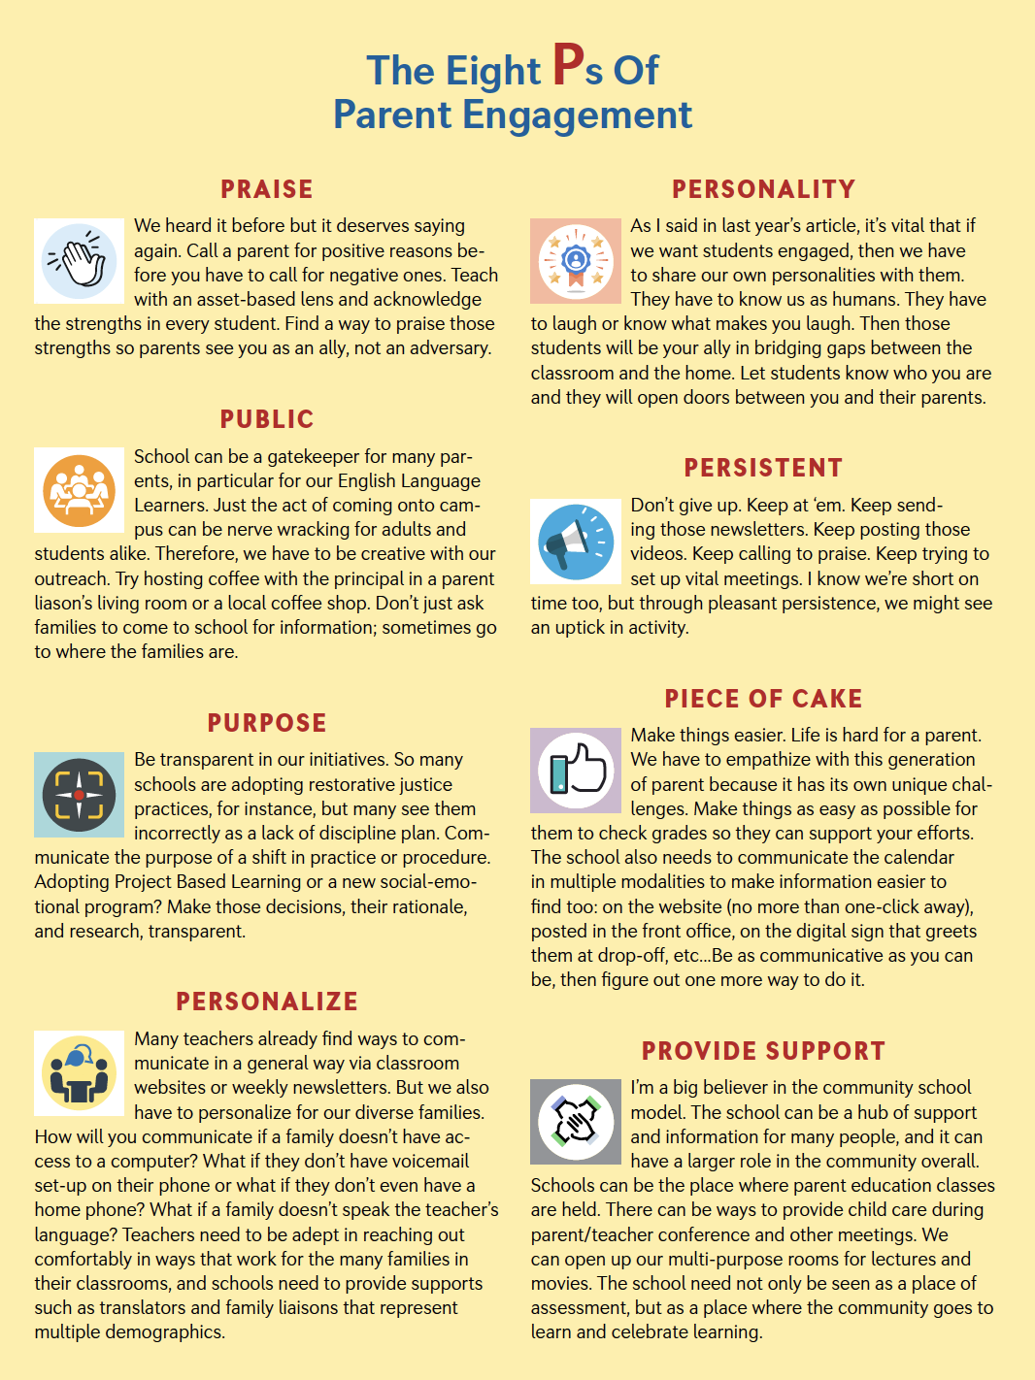
Figure 1. The Eight P’s of Parent Engagement (Wolpert-Gawron, H. 2019)

